**Cyber bullying in online games（如何应对网络游戏的霸凌）**

Question 8 (Sub-question 5):Automatically identify and block illegal words (overall evaluation, 1 point is very bad) [Matrix question]

|  |  |  |  |  |  |  |  |  |
| --- | --- | --- | --- | --- | --- | --- | --- | --- |
| X\Y | don't know unknown | very worse | poor worse | normal | better nice | very nice very nice | Subtotal | The average score |
| League of Legends | 7 (6.67%) | 10 (9.52%) | 24 (22.86%) | 34 (32.38%) | 24 (22.86%) | 6 (5.71%) | 105 | 2.92 |
| DOTA2 | 2 (4.26%) | 5 (10.64%) | 6 (12.77%) | 18 (38.30%) | 11 (23.40%) | 5 (10.64%) | 47 | 3.11 |
| CS:GO | 1 (2.44%) | 4 (9.76%) | 7 (17.07%) | 13 (31.71%) | 11 (26.83%) | 5 (12.20%) | 41 | 3.15 |
| Battlefield (Battlefield series) | 2 (5.88%) | 2 (5.88%) | 3 (8.82%) | 14 (41.18%) | 7 (20.59%) | 6 (17.65%) | 34 | 3.38 |
| World of Tanks | 1 (3.85%) | 2 (7.69%) | 3 (11.54%) | 9 (34.62%) | 5 (19.23%) | 6 (23.08%) | 26 | 3.4 |
| others | 16 (18.39%) | 12 (13.79%) | 18 (20.69%) | 24 (27.59%) | 15 (17.24%) | 2 (2.30%) | 87 | 2.68 |

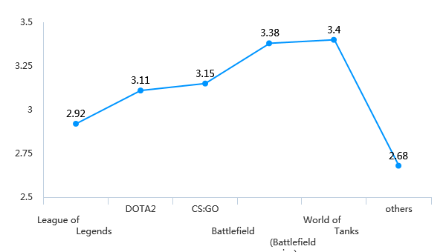

Question 10 (Sub-question 5):Report to the operator (overall evaluation, 1 point is very bad) [Matrix question]

|  |  |  |  |  |  |  |  |  |
| --- | --- | --- | --- | --- | --- | --- | --- | --- |
| X\Y | don't know unknow | very worse | poor worse | normal | better nice | very nice very nice | Subtotal | The average score |
| League of Legends | 9 (8.57%) | 11 (10.48%) | 24 (22.86%) | 28 (26.67%) | 25 (23.81%) | 8 (7.62%) | 105 | 2.95 |
| DOTA2 | 2 (4.26%) | 4 (8.51%) | 8 (17.02%) | 14 (29.79%) | 15 (31.91%) | 4 (8.51%) | 47 | 3.16 |
| CS:GO | 3 (7.32%) | 1 (2.44%) | 7 (17.07%) | 12 (29.27%) | 11 (26.83%) | 7 (17.07%) | 41 | 3.42 |
| Battlefield (Battlefield series) | 3 (8.82%) | 0 (0.00%) | 7 (20.59%) | 7 (20.59%) | 10 (29.41%) | 7 (20.59%) | 34 | 3.55 |
| World of Tanks | 2 (7.69%) | 0 (0.00%) | 2 (7.69%) | 6 (23.08%) | 12 (46.15%) | 4 (15.38%) | 26 | 3.75 |
| others | 15 (17.24%) | 8 (9.20%) | 16 (18.39%) | 21 (24.14%) | 22 (25.29%) | 5 (5.75%) | 87 | 3 |

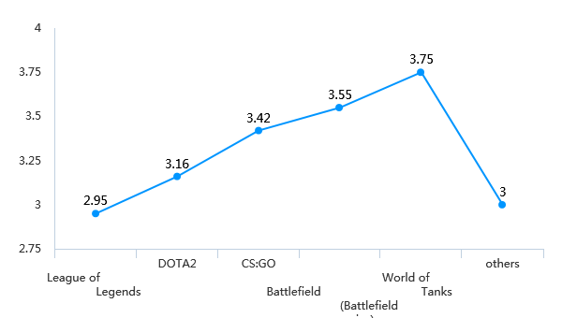

Question 12 (Sub-question 5):Player education, through creating a good game community atmosphere, allowing players to consciously maintain the game environment (overall evaluation, 1 point is very bad) )) [Matrix question]

|  |  |  |  |  |  |  |  |  |
| --- | --- | --- | --- | --- | --- | --- | --- | --- |
| X\Y | don't know unknow | very worse | poor worse | normal | better nice | very nice very nice | Subtotal | The average score |
| League of Legends | 12 (11.43%) | 17 (16.19%) | 20 (19.05%) | 30 (28.57%) | 18 (17.14%) | 8 (7.62%) | 105 | 2.78 |
| DOTA2 | 4 (8.51%) | 5 (10.64%) | 6 (12.77%) | 17 (36.17%) | 11 (23.40%) | 4 (8.51%) | 47 | 3.07 |
| CS:GO | 6 (14.63%) | 5 (12.20%) | 6 (14.63%) | 14 (34.15%) | 5 (12.20%) | 5 (12.20%) | 41 | 2.97 |
| Battlefield (Battlefield series) | 4 (11.76%) | 2 (5.88%) | 4 (11.76%) | 11 (32.35%) | 9 (26.47%) | 4 (11.76%) | 34 | 3.3 |
| World of Tanks | 2 (7.69%) | 2 (7.69%) | 2 (7.69%) | 10 (38.46%) | 4 (15.38%) | 6 (23.08%) | 26 | 3.42 |
| others | 18 (20.69%) | 12 (13.79%) | 13 (14.94%) | 24 (27.59%) | 15 (17.24%) | 5 (5.75%) | 87 | 2.83 |

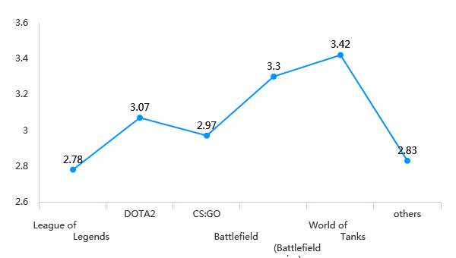

Question 14 (Sub-question 5):automated disciplinary system and player reform system in League of Legends (overall evaluation, 1 point is very bad) [Matrix question]

|  |  |  |  |  |  |  |  |  |
| --- | --- | --- | --- | --- | --- | --- | --- | --- |
| X\Y | don't know unknow | very worse | poor worse | normal | better nice | very nice very nice | Subtotal | The average score |
| League of Legends | 16 (15.24%) | 7 (6.67%) | 19 (18.10%) | 29 (27.62%) | 21 (20%) | 13 (12.38%) | 105 | 3.16 |
| DOTA2 | 2 (6.25%) | 1 (3.13%) | 4 (12.5%) | 13 (40.63%) | 7 (21.88%) | 5 (15.63%) | 32 | 3.37 |
| CS:GO | 3 (10%) | 0 (0.00%) | 5 (16.67%) | 12 (40%) | 6 (20%) | 4 (13.33%) | 30 | 3.33 |
| Battlefield (Battlefield series) | 1 (4.55%) | 0 (0.00%) | 2 (9.09%) | 9 (40.91%) | 6 (27.27%) | 4 (18.18%) | twenty two | 3.57 |
| World of Tanks | 1 (5.88%) | 0 (0.00%) | 0 (0.00%) | 7 (41.18%) | 6 (35.29%) | 3 (17.65%) | 17 | 3.75 |
| others | 3 (13.64%) | 1 (4.55%) | 5 (22.73%) | 9 (40.91%) | 3 (13.64%) | 1 (4.55%) | twenty two | 2.89 |

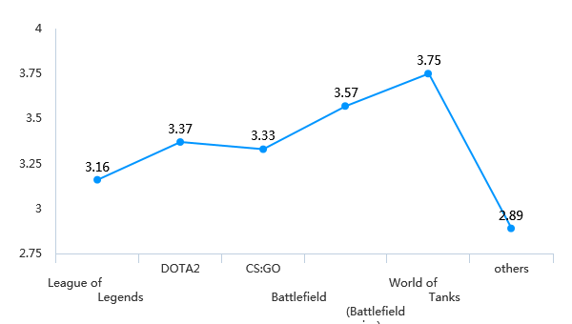

Question 16 (Sub-question 5):Block user, delete post and/or flag content when toxic behavior is occurring (overall evaluation, 1 point is very bad) [Matrix question]

|  |  |  |  |  |  |  |  |  |
| --- | --- | --- | --- | --- | --- | --- | --- | --- |
| X\Y | don't know unknow | very worse | poor worse | normal | better nice | very nice very nice | Subtotal | The average score |
| League of Legends | 14 (13.33%) | 7 (6.67%) | 14 (13.33%) | 37 (35.24%) | 25 (23.81%) | 8 (7.62%) | 105 | 3.14 |
| DOTA2 | 4 (8.51%) | 0 (0.00%) | 8 (17.02%) | 21 (44.68%) | 11 (23.40%) | 3 (6.38%) | 47 | 3.21 |
| CS:GO | 6 (14.63%) | 1 (2.44%) | 6 (14.63%) | 19 (46.34%) | 6 (14.63%) | 3 (7.32%) | 41 | 3.11 |
| Battlefield (Battlefield series) | 5 (14.71%) | 0 (0.00%) | 7 (20.59%) | 9 (26.47%) | 9 (26.47%) | 4 (11.76%) | 34 | 3.34 |
| World of Tanks | 3 (11.54%) | 0 (0.00%) | 3 (11.54%) | 10 (38.46%) | 7 (26.92%) | 3 (11.54%) | 26 | 3.43 |
| others | 15 (17.24%) | 5 (5.75%) | 10 (11.49%) | 29 (33.33%) | 23 (26.44%) | 5 (5.75%) | 87 | 3.18 |

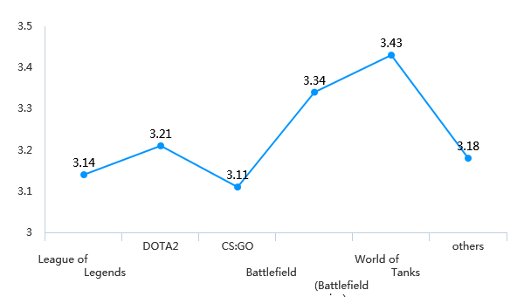

Question 18 (Sub-question 5):In-game rewards to encourage prosocial behavior in the gaming community (overall evaluation, 1 point is very bad) [Matrix question]

|  |  |  |  |  |  |  |  |  |
| --- | --- | --- | --- | --- | --- | --- | --- | --- |
| X\Y | don't know unknow | very worse | poor worse | normal | better nice | very nice very nice | Subtotal | The average score |
| League of Legends | 11 (10.48%) | 8 (7.62%) | 15 (14.29%) | 23 (21.90%) | 34 (32.38%) | 14 (13.33%) | 105 | 2.98 |
| DOTA2 | 4 (8.51%) | 1 (2.13%) | 5 (10.64%) | 17 (36.17%) | 14 (29.79%) | 6 (12.77%) | 47 | 3.15 |
| CS:GO | 5 (12.20%) | 2 (4.88%) | 4 (9.76%) | 13 (31.71%) | 11 (26.83%) | 6 (14.63%) | 41 | 3 |
| Battlefield (Battlefield series) | 3 (8.82%) | 1 (2.94%) | 1 (2.94%) | 10 (29.41%) | 12 (35.29%) | 7 (20.59%) | 34 | 3.41 |
| World of Tanks | 2 (7.69%) | 0 (0.00%) | 0 (0.00%) | 7 (26.92%) | 10 (38.46%) | 7 (26.92%) | 26 | 3.69 |
| others | 15 (17.24%) | 6 (6.90%) | 10 (11.49%) | 16 (18.39%) | 24 (27.59%) | 16 (18.39%) | 87 | 2.87 |

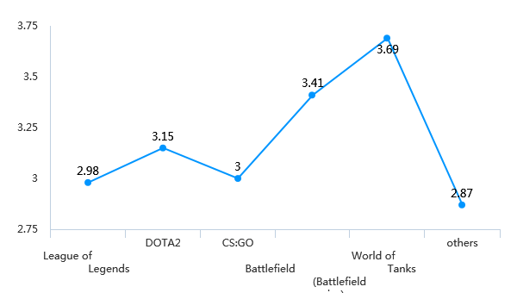

Question 20 (Sub-question 5):Temporary or permanent ban and/or forced withdrawal from game if found at fault (overall evaluation, 1 point is very bad) [Matrix question]

|  |  |  |  |  |  |  |  |  |
| --- | --- | --- | --- | --- | --- | --- | --- | --- |
| X\Y | don't know unknow | very worse | poor worse | normal | better nice | very nice very nice | Subtotal | The average score |
| League of Legends | 10 (9.52%) | 5 (4.76%) | 11 (10.48%) | 35 (33.33%) | 27 (25.71%) | 17 (16.19%) | 105 | 3.10 |
| DOTA2 | 3 (6.38%) | 1 (2.13%) | 4 (8.51%) | 26 (55.32%) | 11 (23.40%) | 2 (4.26%) | 47 | 3 |
| CS:GO | 4 (9.76%) | 1 (2.44%) | 2 (4.88%) | 20 (48.78%) | 7 (17.07%) | 7 (17.07%) | 41 | 3.12 |
| Battlefield (Battlefield series) | 3 (8.82%) | 0 (0.00%) | 2 (5.88%) | 13 (38.24%) | 11 (32.35%) | 5 (14.71%) | 34 | 3.29 |
| World of Tanks | 2 (7.69%) | 0 (0.00%) | 1 (3.85%) | 9 (34.62%) | 10 (38.46%) | 4 (15.38%) | 26 | 3.42 |
| others | 14 (16.09%) | 6 (6.90%) | 6 (6.90%) | 23 (26.44%) | 23 (26.44%) | 15 (17.24%) | 87 | 2.92 |

